**Project Report Template**

**Introduction**

**1.1 overview**

An airplane crash analysis is a detailed investigation into the causes of an aviation accident. The goal of an airplane crash analysis is to identify any factors that contributed to the accident, with the ultimate goal of improving safety and preventing future accidents. The process of conducting an airplane crash analysis typically involves the collection and analysis of a wide range of data, including information about the aircraft and its systems, the operators, and any other relevant factors. This data is typically collected from Kaggle. Once the data has been collected, it is analysed through tableau, to identify any potential causes of the accident. The results of an airplane crash analysis are typically published in a report, which may include recommendations for improving safety and preventing similar accidents in the future. These recommendations may be implemented by the relevant authorities or industry organizations.

**1.2 Purpose**

The objective of analysis is to prevent accidents in the future. This statement is not as trivial as it looks: to many the objective is to identify those who were responsible, or simply to fulfill a legal or organisational requirement. The goal of an airplane crash analysis is to identify any factors that contributed to the accident, with the ultimate goal of improving safety and preventing future accidents.The analysis can provide closure to the families and loved ones of the victims of the crash, as well as to the broader public. It can also help to improve public confidence in the aviation industry by identifying and addressing any safety issues that may have contributed to the incident.

**Problem Definition & Design Thinking**

**2.1 Empathy map**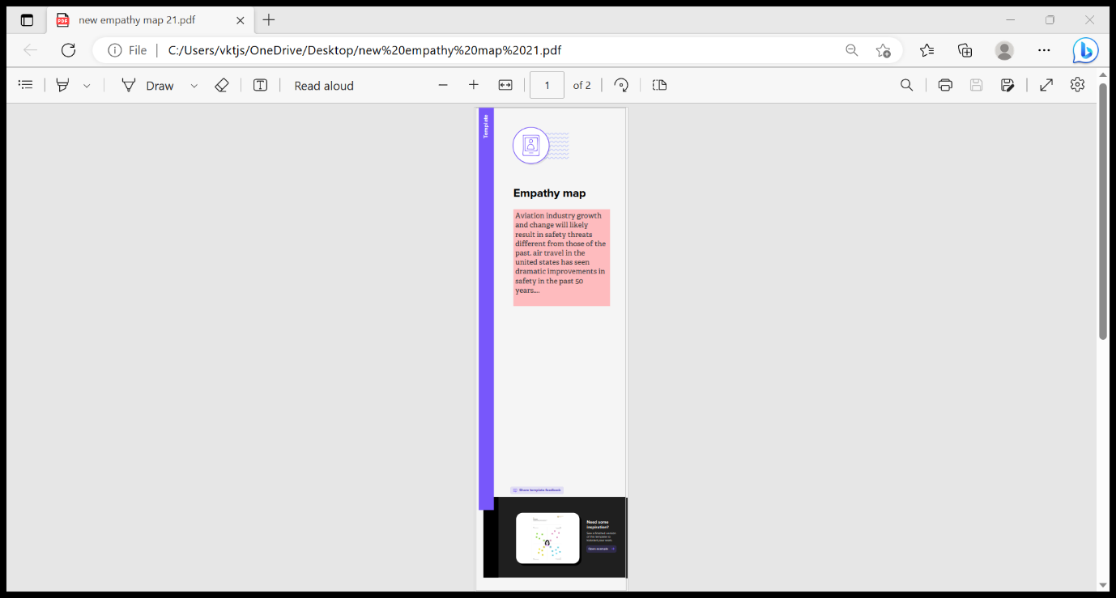

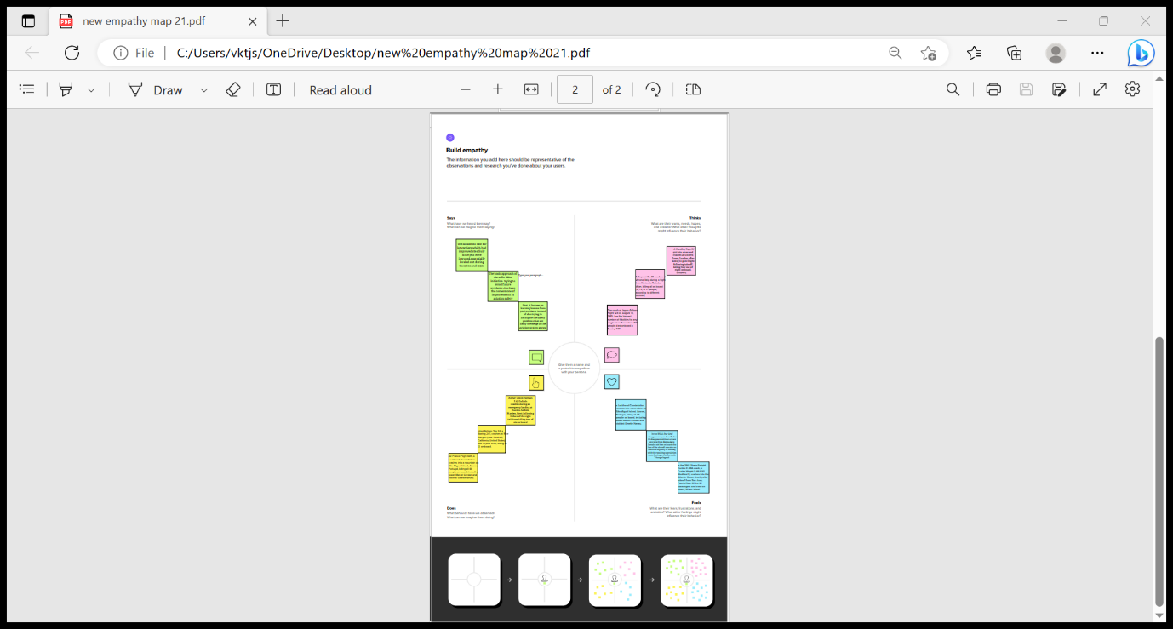

**2.2 Ideation & Brainstorming Map**

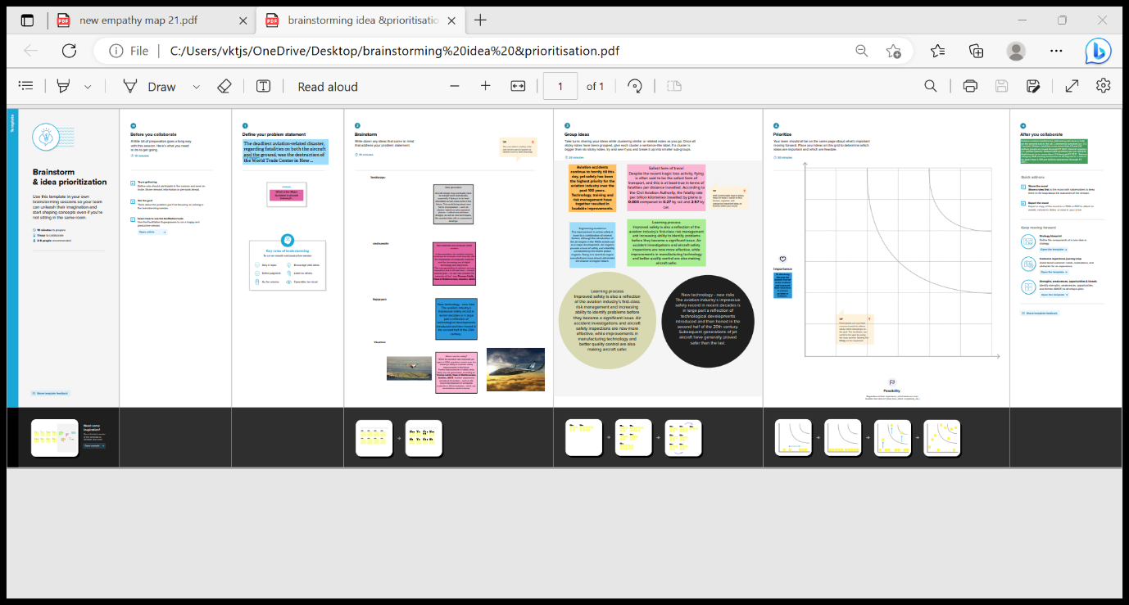

**RESULT**

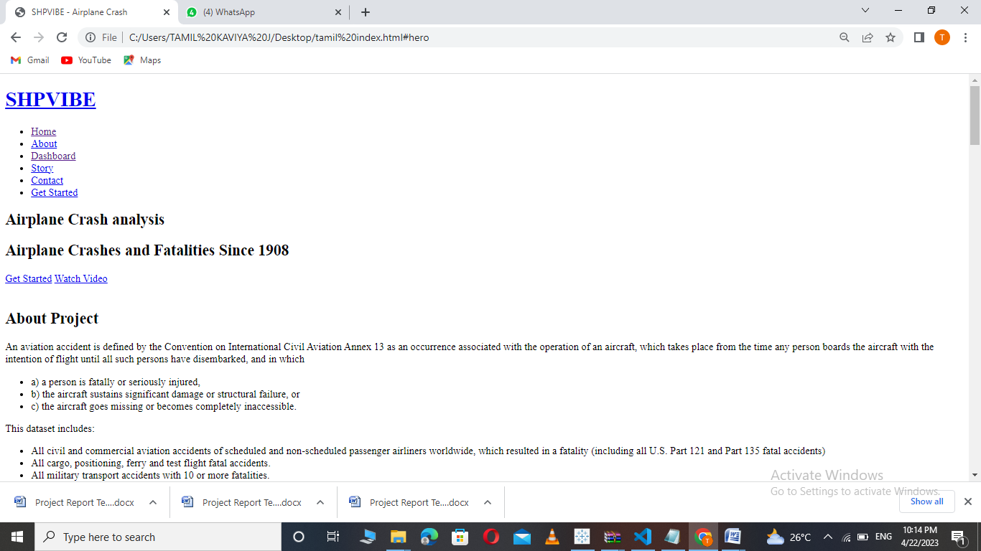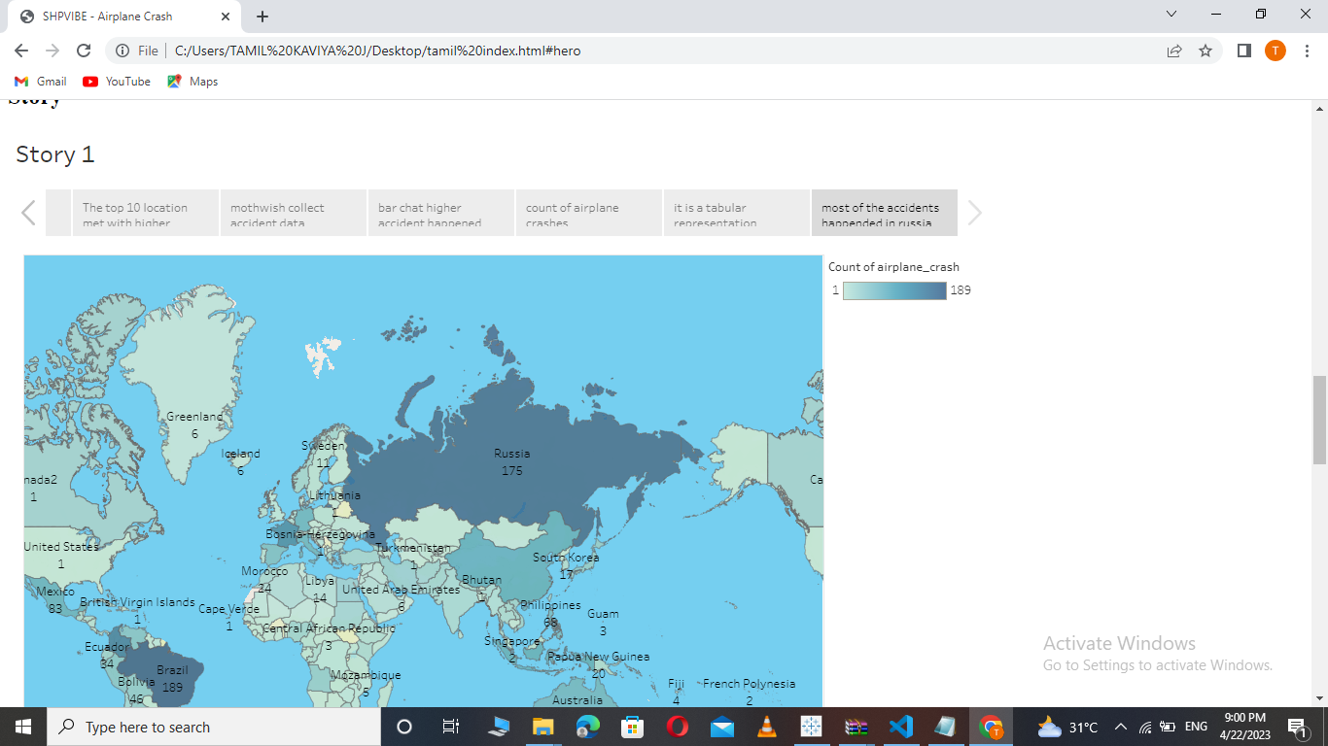

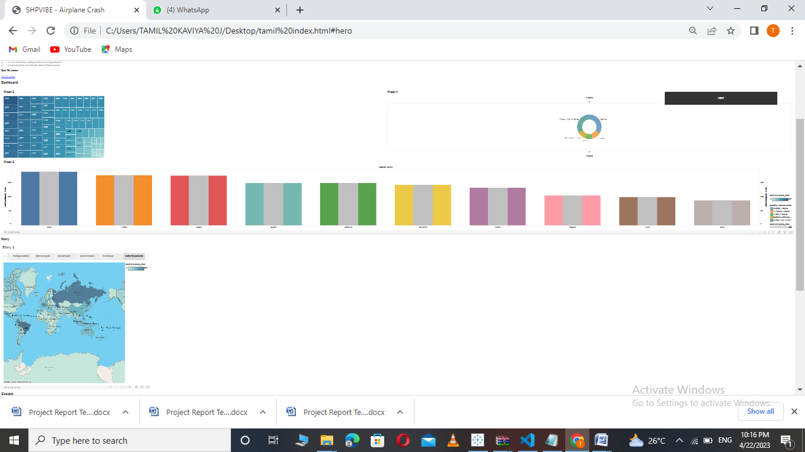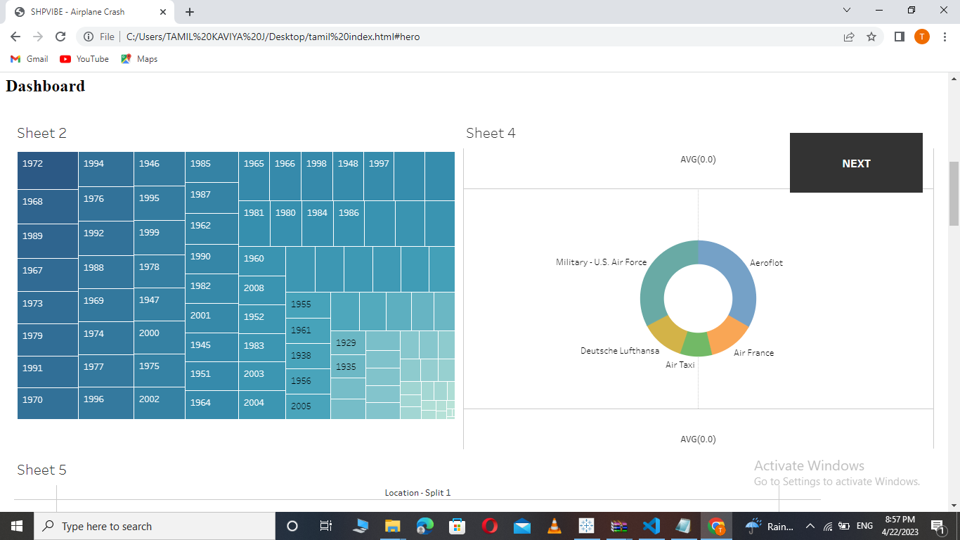

**ADVANTAGES OF AIR TRANSPORT**

**1.Its the fastest way to travel long distances**

**2.Its the most efficient way to travel long distances.**

**3.Plan can carry a lot of weight**

**4.You can fly everywhere**

**5.It’s safe**

**DISADVANTAGE OF AIR TRANSPORT**

**1.Going through security**

**2.The food**

**3. Expensive airports**

**4.Fear of flying**

**5.Environmental impact**

**APPLICATION OF AIRPLANE**

**Consider and analyse the maximum accident**

**Notedown your ideas and solution**

**Carry out the solution**

**Execute the airport surveys**

**CONCLUSION**

**The advantage and disadvantage of startup bussiness you need to compile your team .The next 5 to 10 years recruit atleast a couple of experienced employees and again more experience before putting your head.**

**FUTURE OF AVIATION**

**The aviation sector growing fast and will continue to grow**

**APPENDIX**

**A Source code**

**Attach the code for the solution built**

**4.You can fly everywhere**

**5.**

